Yottacontrol A-1019 Analog/Digital Input module Quick Start

Yottacontrol A-1019 build-in 8AI, 4DI, the Analog Input can support 0/4-20 mA, Thermocouple Type J, K, T, E, R,S B and Thermistor Type 10K-2, 10K-3, 6.8K, 4.7K, 3.3K, 3K, 2.7K, 2.2252K, 2.1K, 2K, 1.5K, 1K.
The A-1019 initial AI specification is setup for 0/4-20mA mode. And the communication parameter is ID: 1, Baud Rate: 9600, Parity: None, Stop bit:1. If would like to modify the communication parameter and Analog Input mode, can over the A-1019’s USB port or RS-485 port to implement it.
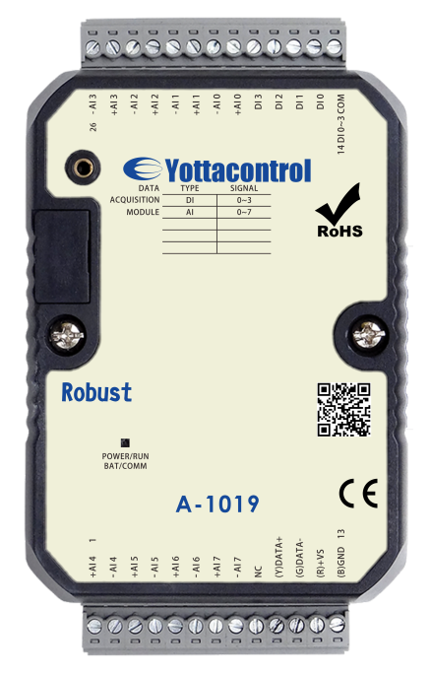

Before the regular use, must finish the related setup process. And prepare below items to finish the setup.
- Download and install the USB driver from below web link.
http://www.yottacontrol.com/download/A5X_USB_DRIVER.rar
- Download and install the YottaUtility software from below web link.
http://www.yottacontrol.com/download/YOTTA_UTY.rar
- Power on the A-1019 and turn the back switch to Init mode. Over the USB or RS-485 to link A-1019 and PC.。
- Open the YottaUtility software.
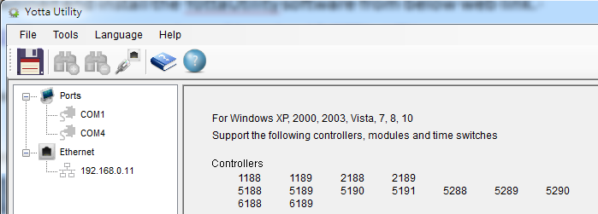
- Click the to refresh the COM port.

- Click the related COM port.
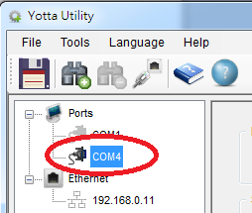
- Click the to search module.
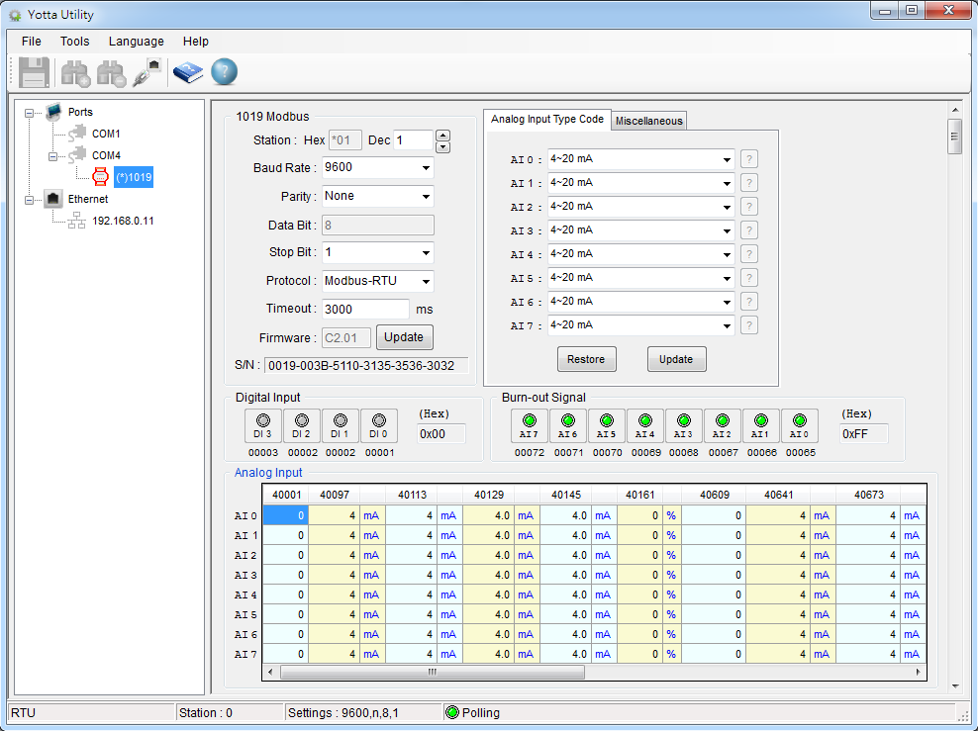
- Can setup the communication parameter from below photo. When finish the setup, must click the Update button.。
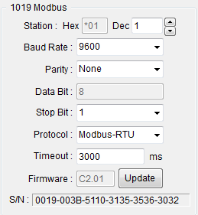
- Can setup the Analog Input mode from below photo. When finish the setup, must click the Update button.
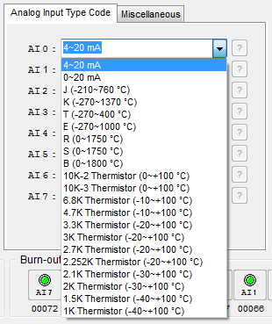
- When complete above step 9 Analog Input mode modify and click the Update button, can click to refer Analaog Input mode specificaion table.
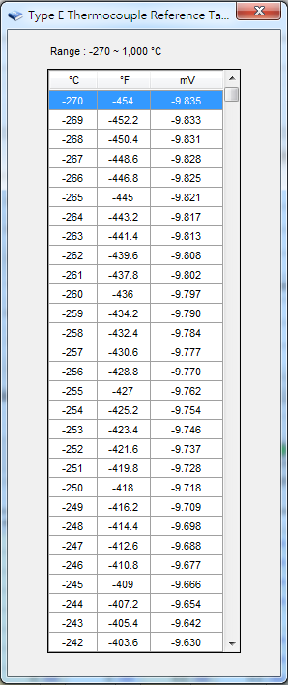
- Can setup the temperature compensation when choose the Thermocouple mode. When finish the setup, must click the Update button.
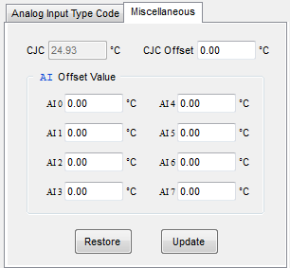
- The A-1019 can support multiple Analog Input mode. When complete above PC software setup, unscrew the device housing screws and remove the internal circuit board to setup the Analog Input Jumper Wire. Each Analog Input channel had its Jumper Wire Pin. The initial setup is for 0/4-20 mA. The jumper indication is as below.
0/4-20 mA: Pin A short.
Thermistor: Pin B short.
Thermocouple: Empty Pin A & B.
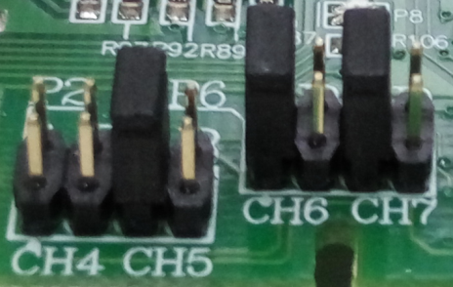 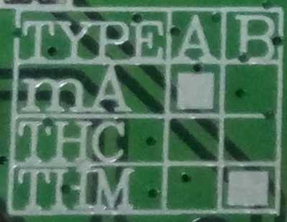
- When complete above Jumper Wire setup, place the circuit board back into the device housing and lock it. Turn the device back switch to Normal mode and power on.
- Done
Note：If the Analog Input mode PC software setup and Jumper Wire not synchronized, the data will be mistake.

